User manual

The IntraRout application can be easily used from its Graphical User Interface, all the commands you need to know will be presented here.
First of all, when you open the application you should be presented with a blank screen such as this:
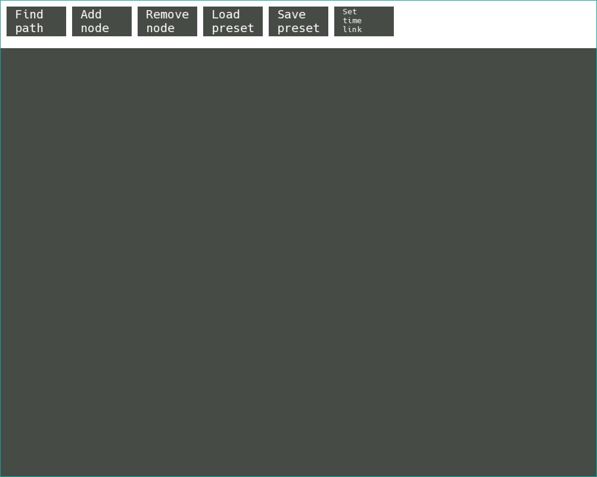
From here you can press the “Load preset” button to load one of the presets saved in the Presets/ folder. Once you open the button, a prompt will appear:
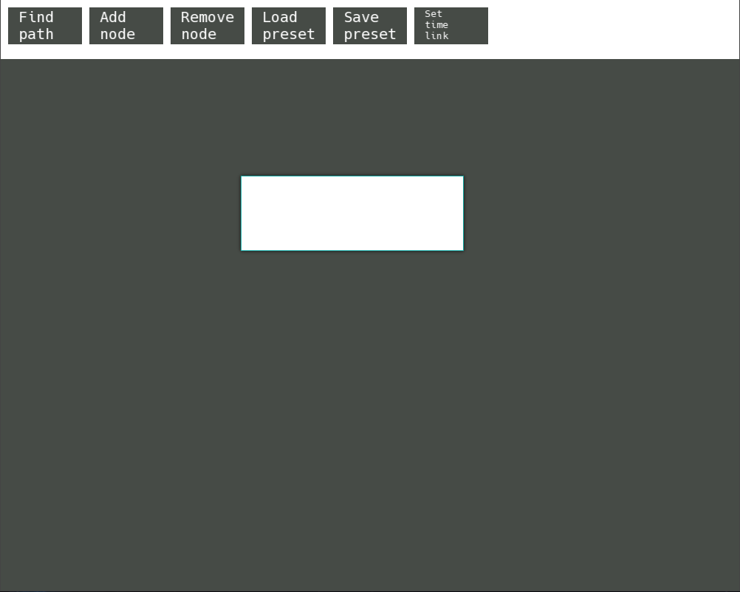
(app with prompt)
You simply have to type the name of the file in the prompt, WITHOUT the file extension. For example to open the preset Presets/Preset1.txt you simply have to type Preset1 inside the prompt and hit enter. This will automatically update the window and load your preset.

Even if you don’t open a preset you can still use all the functionalities of the program and create nodes. To create a node you have to click on the “Add node” button. This will open a prompt in which you have to type a number which will represent the group of the IP (intranet protocol) address . After you press enter, another prompt will show up where you again have to type a number which will represent its index in the IP address. After you enter a valid group and index the new node will appear in the top-left corner of the window, below the top bar. To remove a node you will have to click on the “Remove node” button. Doing so, will turn the button red to indicate you are in the remove node mode. Clicking on any node in this mode will cause that node and all of its connections to be deleted. CAUTION: REMOVING A NODE IS PERMANENT AND THERE IS NO UNDO BUTTON. To exit the remove node mode you simply have to click the “Remove node” button again and will cause it to turn back white.
You can drag any node by hovering your mouse over it, pressing the left mouse button and dragging your mouse while the button is pressed. If you want to stop dragging the node you can release the left mouse button.
If you want to add a connection between to nodes you will first have to right-click on the node from which you want the connection to start. This will turn your node border in a magenta color. If you change your mind, you can click on the same node again causing it to change the border color back to light blue and canceling the operation.
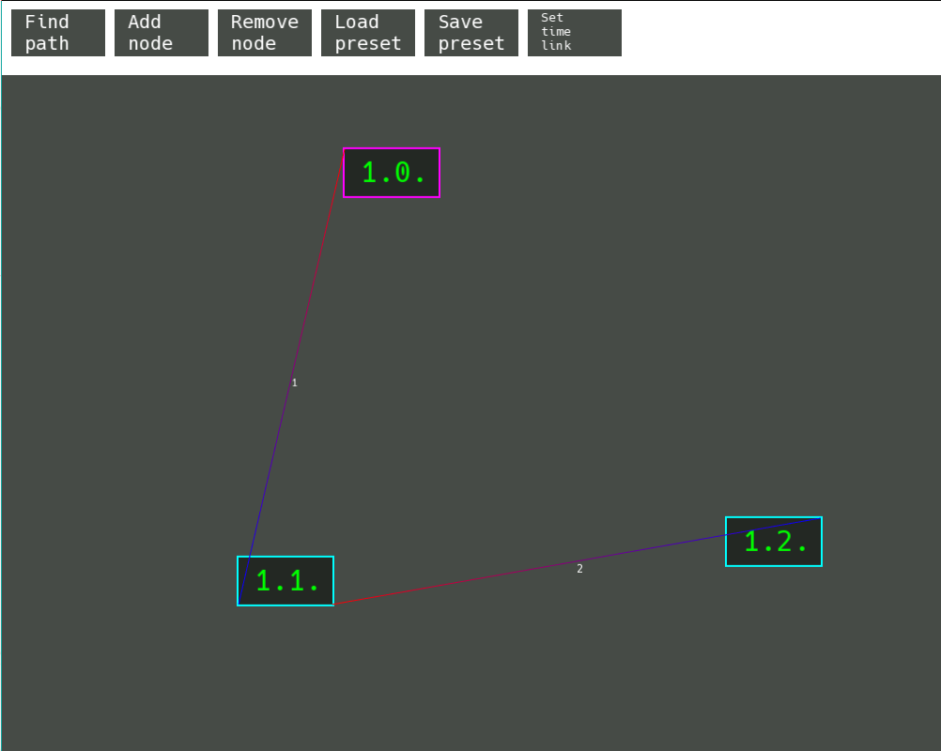
CAUTION: THIS IS AN ORIENTED GRAPH AND THE ORDER IN WHICH YOU CLICK THE NODES IS IMPORTANT. After you click on the second node to which you want your connection to go a prompt will show up in which you have to type an integer value representing the latency to that node (in more general terms, its cost). The red part of the line means that the connection starts from there and the blue part means that the connection ends there.
After modifying a preset, or adding nodes while no preset is loaded you can click the “Save preset” button which will show you a prompt where you can type the name of your new preset, again don’t include the file extension. All the connections, nodes and their positions will be saved. Things such as their color or size will not be saved. If you are modifying an existing preset you can also press enter while there is nothing typed in the prompt to save your modified preset to the same file.
Pressing the “Set time link” button will cause a prompt to pop up. You have to enter a valid decimal number which will set the new time link. Time link refers to the time each action of the pathfinding algorithm will take. For example, a time link of 3 will cause each action of the algorithm to take 3 seconds. You can think of it as “each second for the program is equivalent to 3 real-world seconds”. A time link of 0 will mean there is no delay. The default time link value is 1.
Finally, the “Find path” button will show you a prompt in which you have to enter the node’s IP address. For example 1.2. and the more generaly form x.y. . After you enter, the first node, a second prompt will show up for the address of the end node. After entering 2 valid nodes another winow will show up containing buttons representing the search algorithms to use. Click on any of them and the window will close automatically and the search will begin. After the search ends, if there is a valid path between the nodes, all the nodes involved in the path will have their border turn green and a small number representing the order in which to be traversed will appear. If there is no path between the 2 nodes entered, they will both red.

